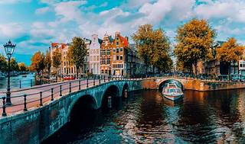

Explore

Certainly! In the realm of technology, a **canal** refers to a **natural or artificial waterway** used for various purposes such as navigation, crop irrigation, water supply, or drainage. [Despite advancements in air and ground transportation, inland waterways continue to play a vital role in many areas1](https://www.britannica.com/technology/canal-waterway).

Here are **five reference links** where you can learn more about canals and inland waterways:

1. [**Britannica**](https://www.britannica.com/technology/canal-waterway): This comprehensive article covers the history of canal building, construction techniques, and major inland waterways worldwide.
2. [**Modern Waterway Engineering**](https://www.britannica.com/technology/canal-waterway/Modern-waterway-engineering): Explore the engineering, construction, and maintenance aspects of canals.
3. [**Wikipedia**](https://en.wikipedia.org/wiki/Canal): Learn about canals as artificial waterways used for drainage management, flood control, irrigation, and water transport.
4. [**Canals and Inland Waterways**](https://www.britannica.com/technology/canal-waterway): Dive deeper into the topic with Britannica’s detailed information.
5. [**Canals and Inland Waterways**](https://www.britannica.com/technology/canal-waterway): Another Britannica resource that provides insights into the significance and functions of canals.

Feel free to explore these resources to enhance your understanding of canals! 🌊🚢